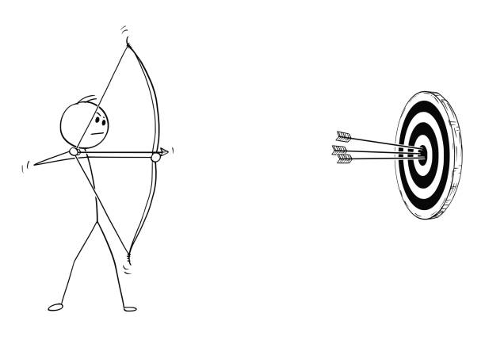

***SCBA***

**3D Target League**

**2024 Thursday Night Outdoor League** Shoots

***Open to All***

***Every Thursday Evening for 9 weeks!!!***

***June 13 – August 19, 2024***

The SCBA will be setting up (14) - 3D targets every Thursday evening for the 2023 outdoor league. Participants will shoot two arrows per target over 8 competitive weeks, week 9 is the awards week. Scores from competitors best 6 weeks will be averaged, and cash awards will be paid for each competitive class. Awards will be determined at the end of season based on number of participants in each class.

Registration: 4:30pm-630pm and weekly competitors must start by 6:30pm

Targets start coming down at 8pm

Weekly Entree Fees:

Adult & Senior members **$10** / nonmembers **$15**

Young Adult 15-17 members **$5** / nonmembers **$5**

Youth & Cub14 and under are **FREE**

Binoculars and rangefinders are permitted on all Compound Classes

No rangefinders are permitted in any Traditional Classes

Classes

Adult Male 4 classes: Senior 55+ (Male and Female) / Adult Freestyle & Unlimited/ / Adult Traditional

Adult Women 3 classes: Adult Freestyle & Unlimited/ / Adult Traditional (Women 55+ can shoot with Senior Class or Women’s)

Young Adult Boys (15-17) 2 classes: Young Adult open / Young Adult Traditional

Young Adult Girls (15-17) 2 classes: Young Adult open / Young Adult Traditional

Youth (12-14) 2 classes: Youth open / Youth Traditional

Cub (8-11) 2 classes: Cub open / Cub Traditional

Mini-cub (7 and under) 2 classes: Cub open / Cub Traditional

For more information, visit

http://www.scbaarchery.org.

SCBA operates in cooperation with Bernalillo County Parks and Recreation.

NO smoking NO drugs or alcohol NO firearms