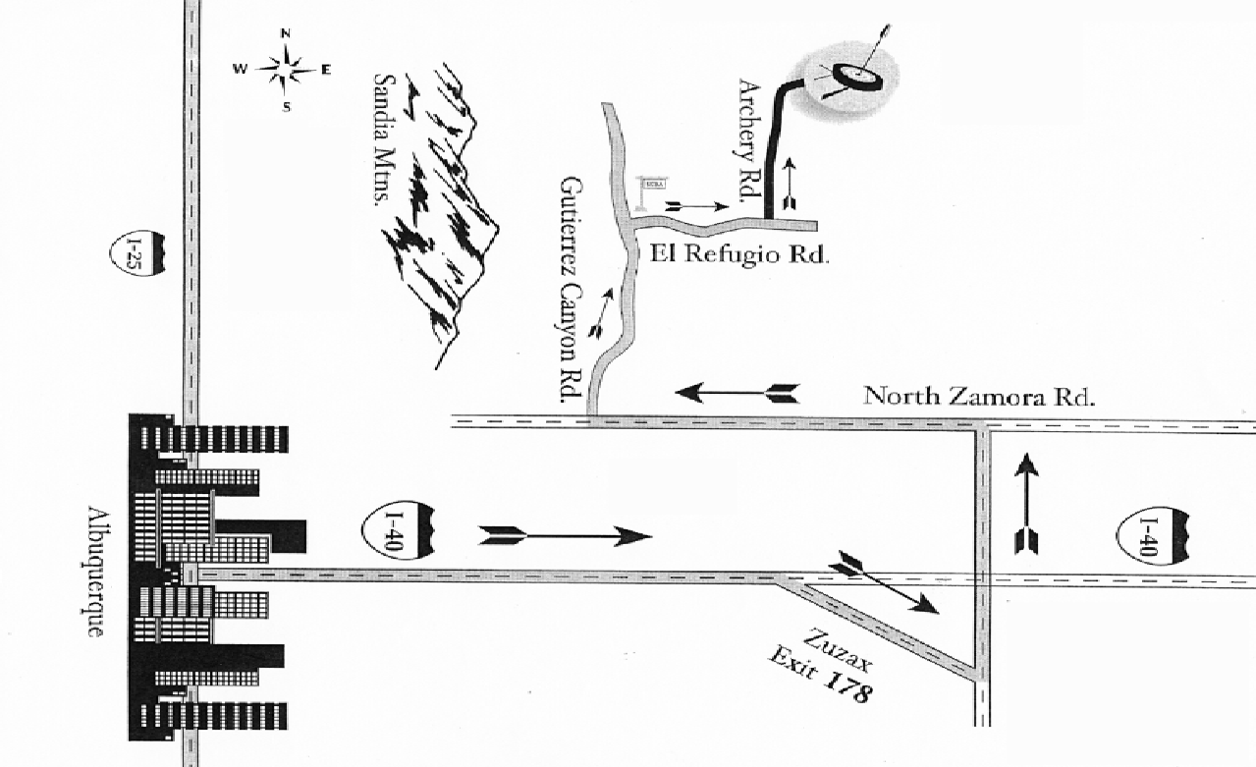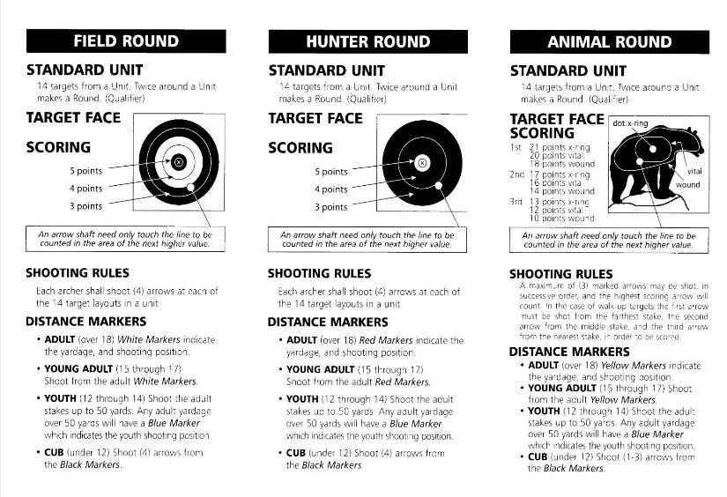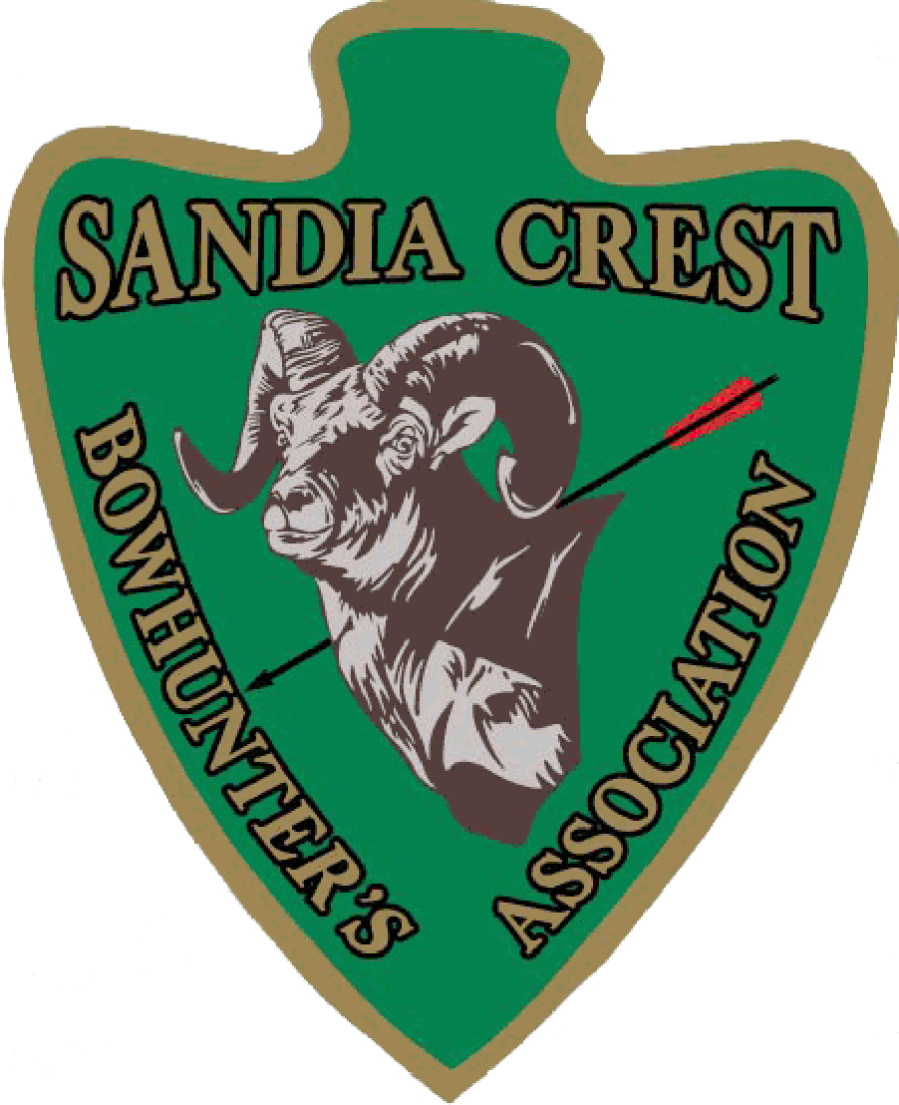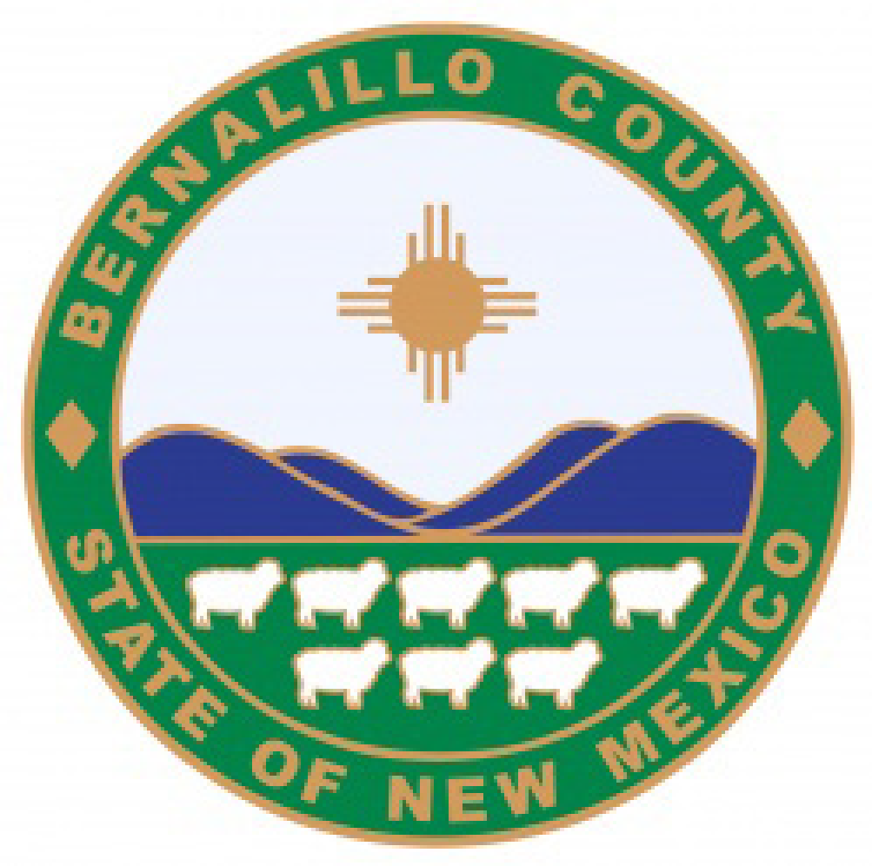

**Saturday April 19, 2025**

**Open to All**

The SCBA will be hosting a NFAA style shoot on Saturday, April 19th. The *Half-n-Half* will feature a ½ competition Hunter Round followed by a ½ competition Animal Round. Scoring will be based on NFAA competition rules and the official NFAA targets. The combined score will determine division winners.

If you haven’t shot an NFAA outdoor competition before, they are lots of fun. This competition will be open to everyone; you don’t have to be a member of the NFAA or the SCBA to compete. Just come on out and enjoy the day!!!!!

**Prizes**- $15 of proceeds from registration by division will be paid back to that division for 1st place. If a division has more than 4 participants, then 70% of winnings will be paid to 1st place and 30% to 2nd place, 6 or more 1st place 50%, 2nd place 30%, 3rd place 20%.

**Competitive Classes-** Will be broken out by Senior, Adult, Young Adult, Youth and Cub for both Male and Female and by bow class. The competition classes will be finalized day of and prior to the first arrow. Some classes may be combined to form bigger competitive divisions the day of event. Participants can move to more competitive or a larger division if it is age / category appropriate and decided before the competition first arrow. For competitors 11 and under, no cash prizes will be awarded.

**Registration** 830am- 915am / competition begins at 930am

Entree fee:

$25 per person all ages

**11yrs and under $5 (11 and under no cash prizes)**

For more information visit:

http://www.scbaarchery.org.

SCBA operates in cooperation with Bernalillo County Parks and Recreation.